**US 002-TC 002_002:** **Verify menu icon is available**

Step 1: Navigate to swag labs site

Step 2: Login as "standard_user" into the website

Step 3: look for the drop down menu icon

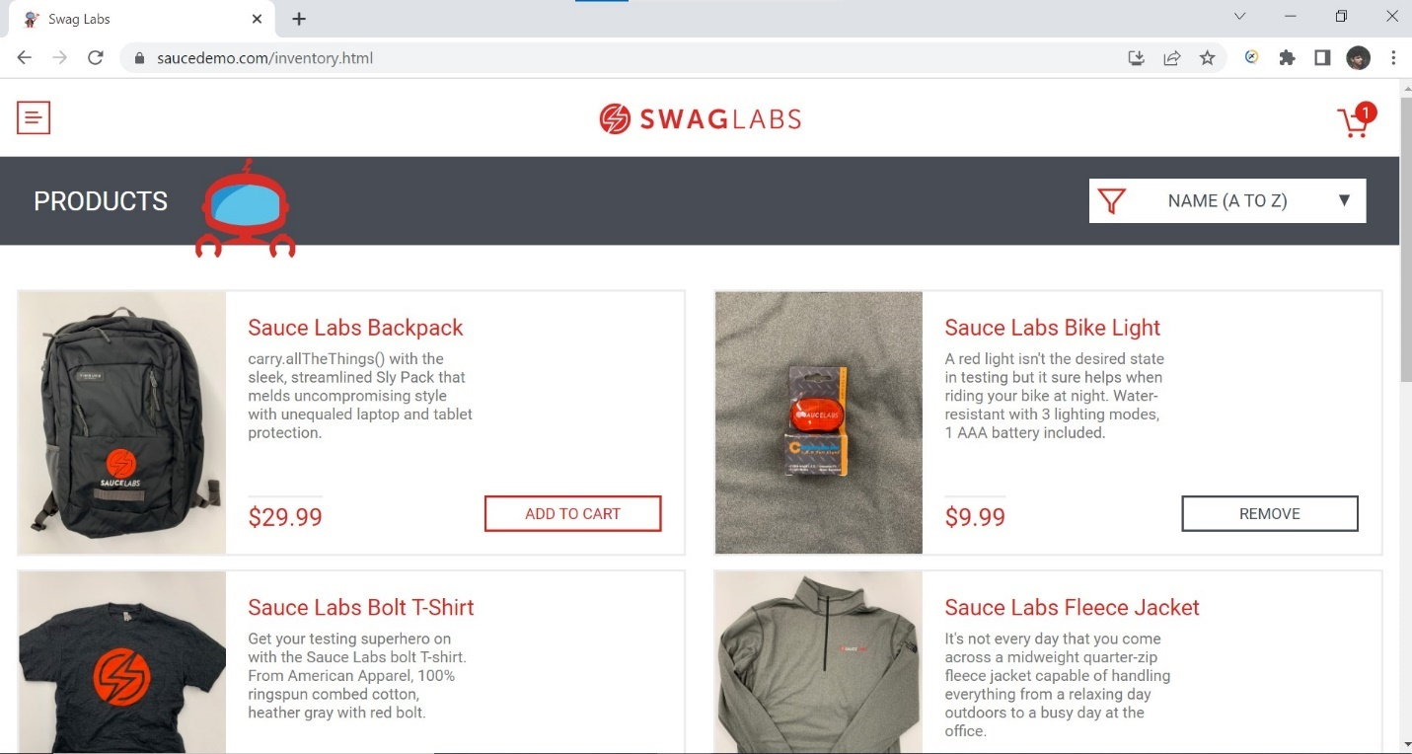

**User is able to see menu icon**

**Test case passed.**